A2007-EUR-FR-Paris Basin-Scraper-Flint-White Patina-Mousterian-Levallois method-Mid Paleolithic-100 kya

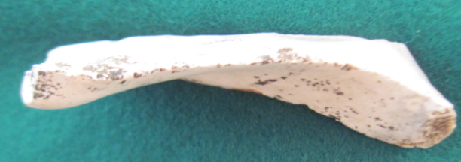 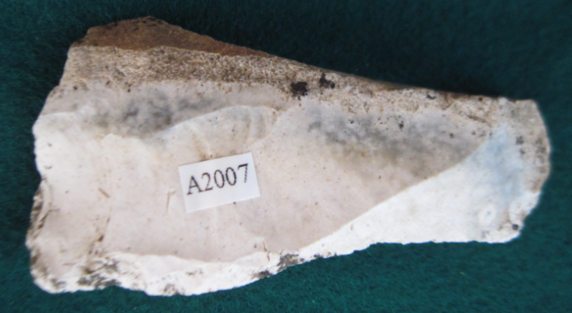

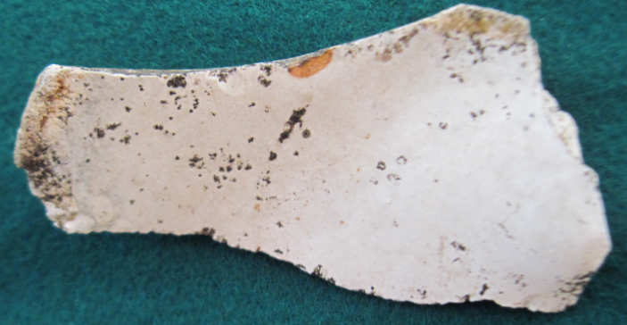

Figs. 1-4. Paris Basin-Scraper-Flint-White Patina-Mousterian-Levallois method-Mid Paleolithic-100 kya

Case no.: 1

Accession Number: A2007

Formal Label: Paris Basin-Scraper-Flint-White Patina-Mousterian-Levallois method-Mid Paleolithic-100 kya

**Display Description:**

The Levalloisian stone flaking technique of prehistoric Europe and Africa is characterized by the production of large flakes from a stone core that was shaped like an inverted, oval tortoise shell. These flakes without further trimming are flat on one side, have sharp cutting edges, and were probably used as skinning or cutting knives.

**LC Classification:** GN772.22

Date or Time Horizon: Mid Paleolithic

Geographical Area: Paris Basin, France

**Map:**

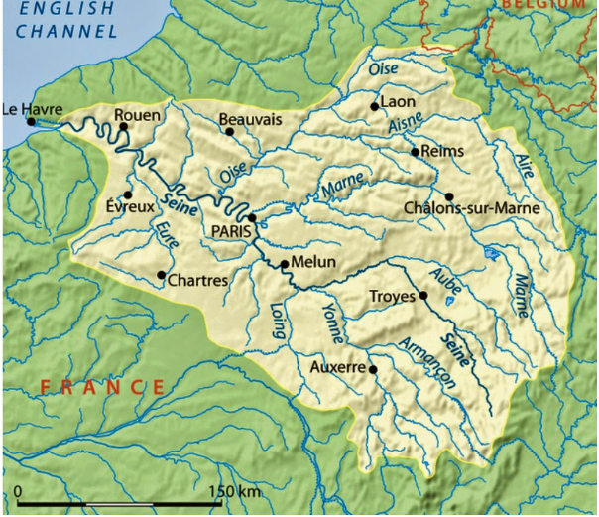

Fig. 5. Map of the Paris Basin after http://1.bp.blogspot.com/-Mgru79LVeCs/U0ptPg3t0AI/AAAAAAAAE3o/uQWFhSX3PKo/s1600/gypsum+Seine+catchment+basin.jpg

**GPS coordinates: 48o 51’ 23”,** 2 **o** 21’8”

Cultural Affiliation: Mid Paleolithic

Medium: Paris Basin flint

Dimensions: L 70.19 mm, 2.76 in

Weight: 1 oz, 31 gm

Condition: original

Provenance: Yonne River, Paris Basin

**Discussion:**

The Levallois technique of core preparation and flake removal is the earliest of the core preparation technologies, and it has four stages. First, edges of a cobble are trimmed into an oval shape. Secondly, the core’s upper surface is trimmed to remove cortex and to produce a ridge running the length of the core. Thirdly, a platform flake is removed from one end of the core to produce an even, flat striking platform for the blow that will detach a flake. Fourthly, the end of the core is struck at the prepared platform site, driving a longitudinal flake off of the core following the longitudinal ridge.

There are two distinct advantages to this technique. First, flakes removed in this manner are already in a preliminary shape, and only require minor modification before being put to use. Secondly, cutting edges are maximized per pound of raw material to produce core tools. The final shape of a tool produced in this manner closely corresponds to the initial shape of the core from which it was struck. Edge retouching is minimized to produce a cutting edge. Therefore, more flakes can be removed from one core producing usable cutting edges with less waste than if the core were thinned into a tool itself.

**References:**

Van Peer, Philip. 1992. *The Levallois reduction strategy*. Monographs in world archaeology, 13. Madison (Wis.) : Prehistory Press.